Name | Photo | English
Özlem Dalkıran | 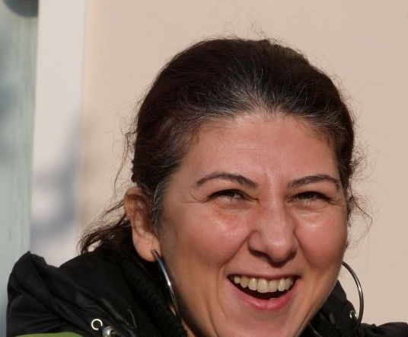 | Writer, translator, human rights activist  Özlem is a long standing and prominent human rights campaigner. She is a founding member, former head of media and former chair for two terms of Amnesty International Turkey. She is an active member of the Citizens’ Assembly (formerly known as Helsinki Citizens Assembly). She has worked as the co-ordinator of the independent news network, Bianet. For many years, she was a member of the Hrant Dink Awards Committee and continues to support the work of the Hrant Dink Foundation. She works as a freelance translator. She cannot live without tea.  QUOTE  “I feel great pride in being part of our human rights community. I value the morale that the domestic and international campaign is generating for us in detention and for human rights defenders out there. I have never felt part of a family as much as I feel right now. So happy that you exist, that we all exist.”  (8 July 2017, Vatan Police Security Headquarters, Istanbul)
Nalan Erkem | 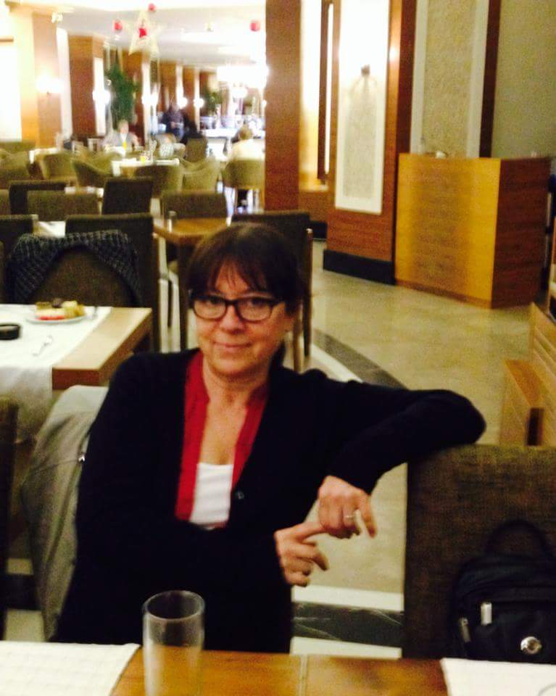 | Nalan Erkem is a lawyer. While she was a member of the board of directors of the Izmir Bar Association between 2002-2004, Nalan supported the project "The Role of Lawyers in the Prevention of Torture" project. She undertook a project monitoring the psychiatric hospitals of Rusihak and the care centres from a human rights perspective. She worked as an expert in projects to prevent violence in juvenile prisons conducted by the Bar Association, in İHD's Don’t Remain Silent to Torture Project, in monitoring of Human Rights Joint Platform’s violence against women project, and in the monitoring of discrimination. She has written and published many reports based on her monitoring work.
Muhammed Şeyhmus Özbekli | 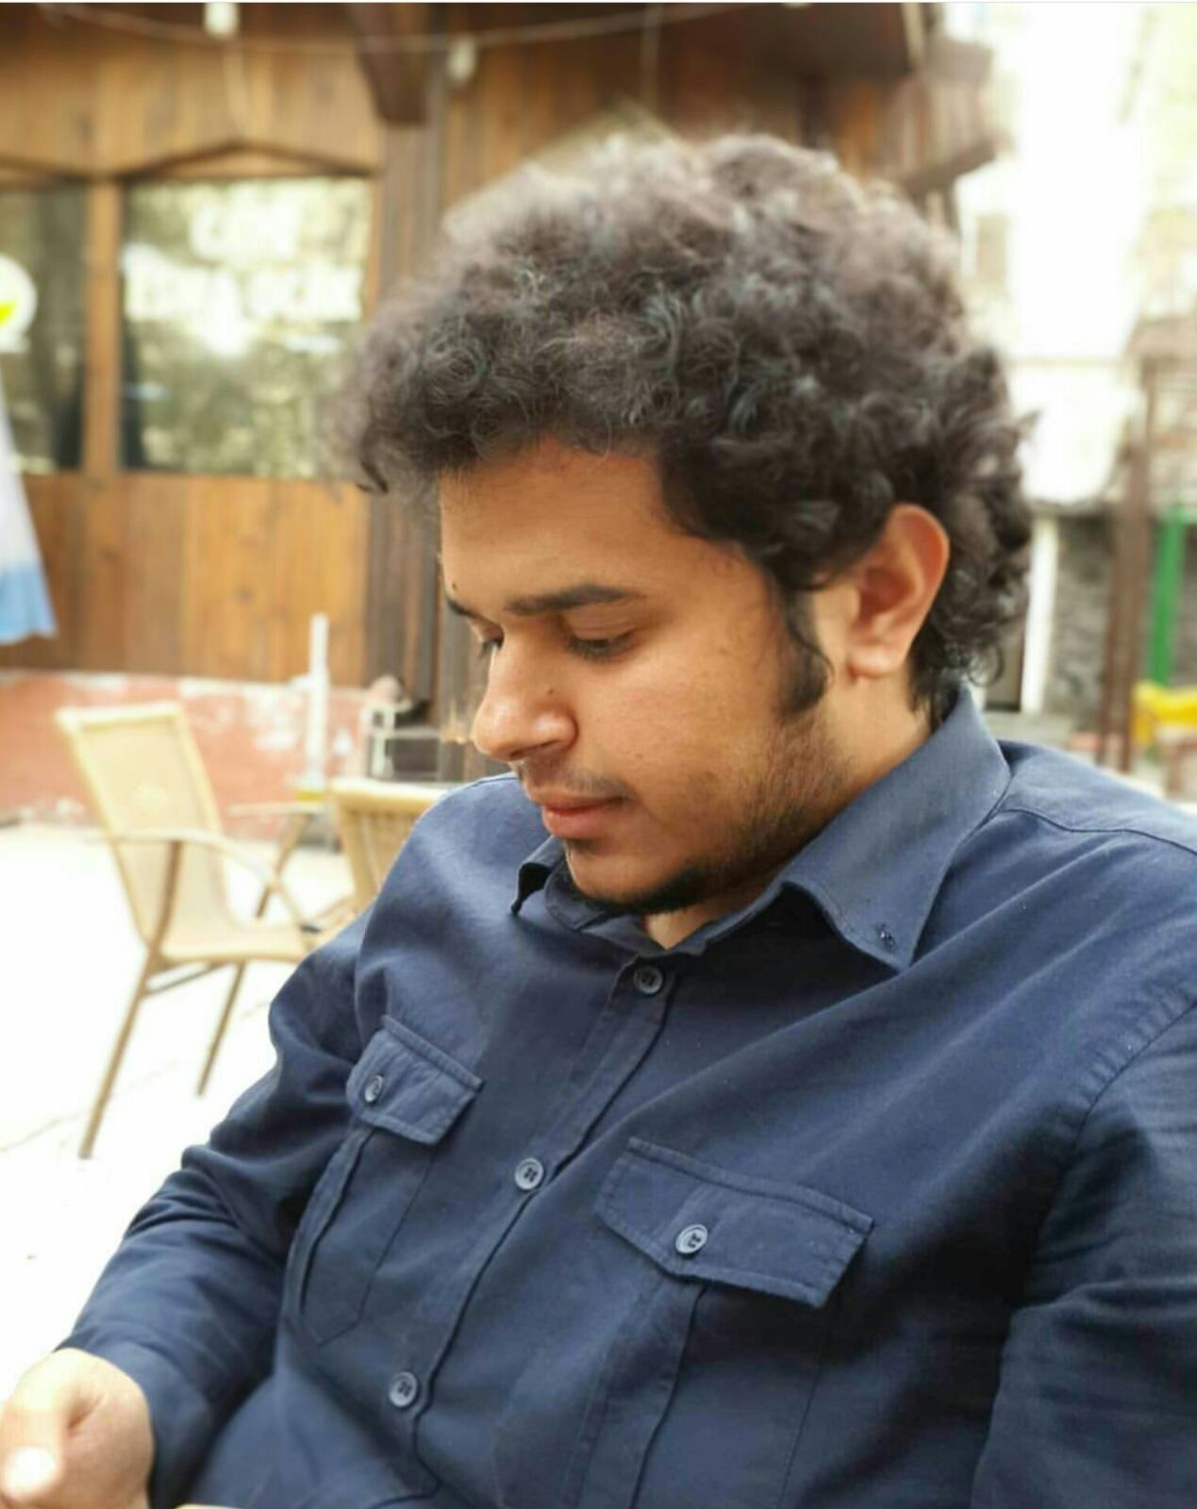 | Şeyhmus Özbekli is a newly qualified lawyer and has been actively involved in human rights for the last four years. He became being active in rights issues in Mazlumder, a well-known human rights organization. More recently, he became involved in the Rights Initiative, established by activists from Mazlumder. He also works in the Human Rights Unit of Diyarbakır Bar Association. He was participating in the Büyükada workshop on behalf of the Rights initiative.
İlknur Üstün | 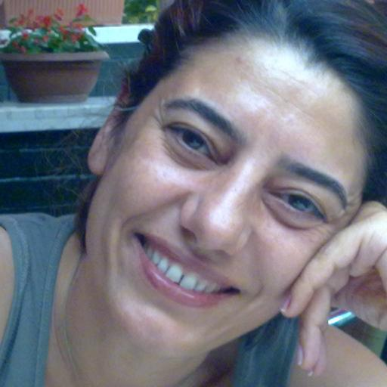 | İlknur Üstün is an activist. She grew up in Ankara and graduated from the Ankara University Department of Philosophy. She continued her graduate studies in the same university. She is actively involved in various women's organizations. Currently, she is head of Ankara KADER (Women’s Association), Turkey Coordinator for the European Women's Lobby and the Coordinator of the Women's Coalition. She is conducting research on gender and local politics and contributes to various academic and other journals.  QUOTE  “All my life I have been part of the struggles for equality and freedom for women and for justice. I carried on believing in the people I walked with in our common struggle and the rightfulness of it. I see once more the importance and necessity of our fight. We are not few, we are not small. I will be proud to continue our struggle until women are equal and free, and we realise justice for everyone.”  (8 July 2017, Vatan Police Security Headquarters, Istanbul)
Nejat Taştan | 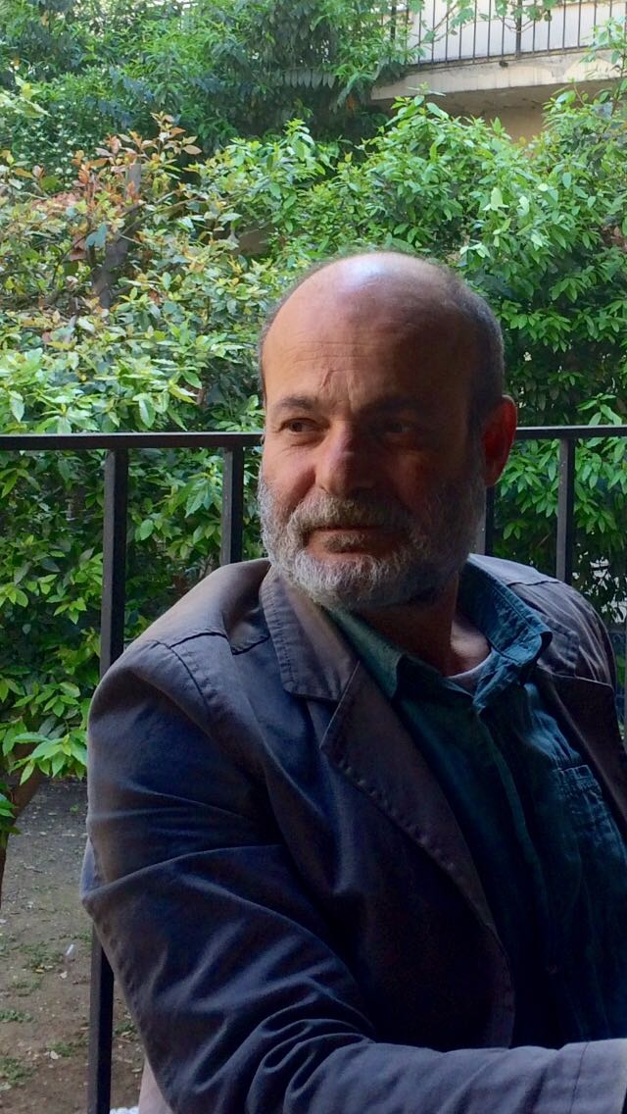 | Nejat Taştan is an activist, who has been advocating for human rights since 1986. He is on the board of the Human Rights Association – and served as its assistant secretary general from 2004-2006. He is a founding member of the Board of the Human Rights Foundation of Turkey. He has been involved in the management and advisory boards of many NGOs working in the fields of human rights and discrimination. He has expertise in many rights and freedoms, including race, ethnicity, religion and belief, disability rights, freedom of peaceful assembly and association, and the right to a fair trial. Within the framework of the Independent Election Monitoring Platform, he has played an active role in monitoring every election in Turkey since 2011. He has been a co-ordinator since 2010 at the Equal Rights Watch Association, of which he is a founding member.
İdil Eser | 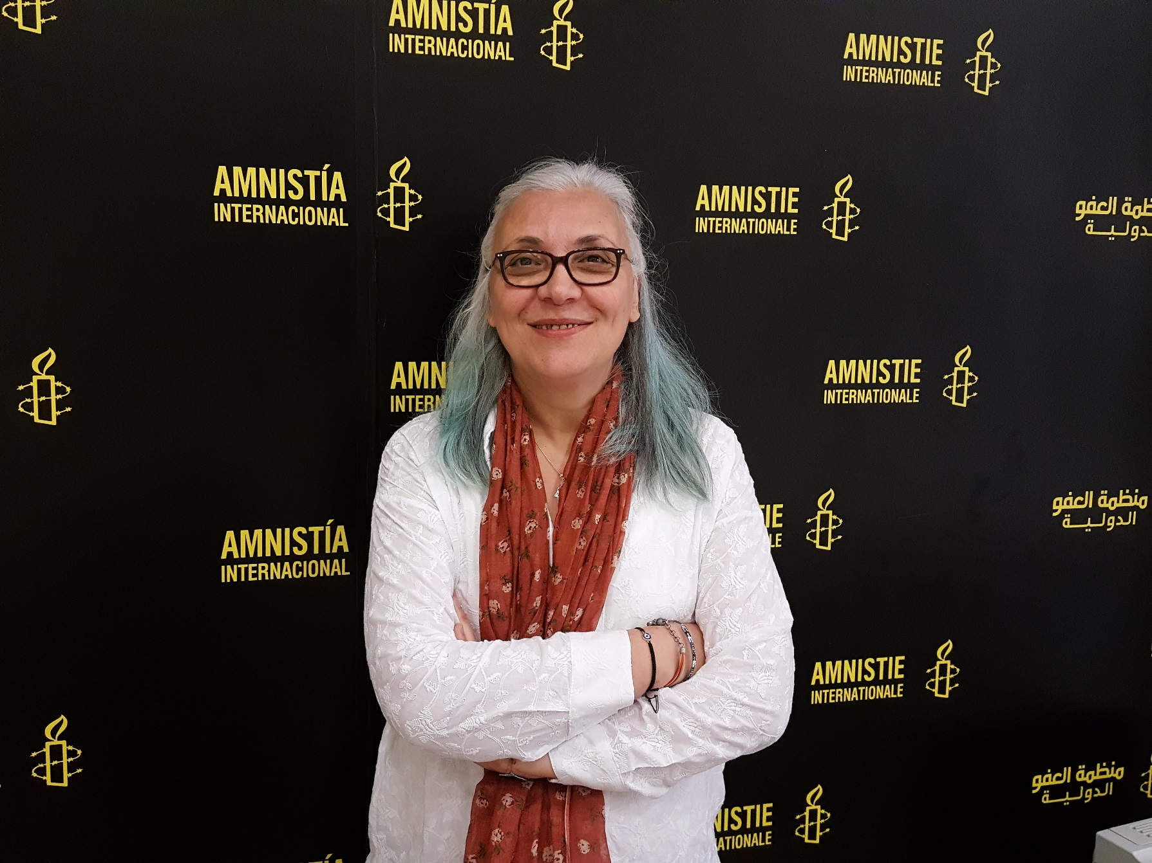 | İdil Eser is an activist and freelance translator and since 2016 has been the Director of Amnesty International Turkey Branch. She has written and published a book entitled Global Development and Market Forces. Idil Eser has held various managerial positions in non-governmental organizations such as the History Foundation, Helsinki Citizens' Assembly and Doctors Without Borders.  QUOTE  We deserve to live in a beautiful world in peace. To be part of the struggle for rights is a great feeling. Solidarity forever.  (8 July 2017, Vatan Police Security Headquarters, Istanbul)
Günal Kurşun | 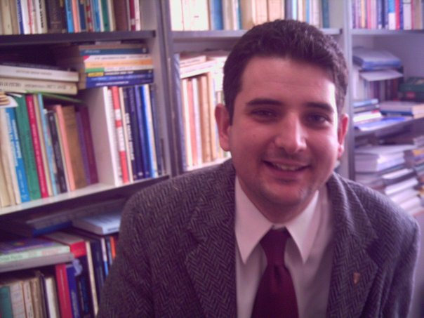 | Günal Kurşun is an academic and lawyer. Prior to his dismissal, he worked as a lecturer at the Faculty of Law at Başkent University in Ankara. He was the first Turkish lawyer working on the International Criminal Court (ICC) in Turkey. He has been advocating for Turkey’s ratification of the Rome Statute that established the ICC and carried out civil society activities on hate crimes. He is an Amnesty International Turkey activist and a member of the Human Rights Agenda Association.  QUOTE  “That a country’s foremost human rights defenders be detained based of absurd allegations and people who have dedicated their lives to opposing violence be accused of being members of an ‘armed terrorist organisation’ is exclusive to Turkey. We are well but we need your support.”  (9 July 2017, Vatan Police Security Headquarters, Istanbul)
Veli Acu | 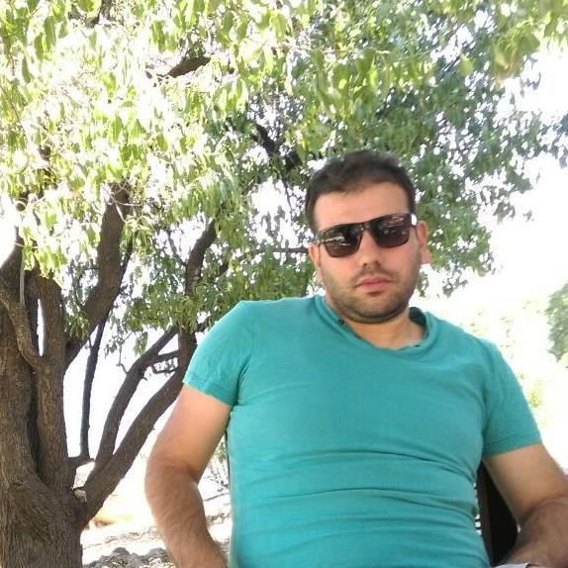 | Veli Acu studied Political Science and Public Administration, and currently studying English Literature at Gaziantep University. He has been a board member of the Human Rights Agenda Association since 2009, and a member of Amnesty International since 2010. He has an academic interest in human rights, nationalism, political theory and civil society. He has held professional positions in a variety of civil society organizations since 2010. Since May 2016, he is a Programme Associate of the UN World Food Programme.  QUOTE  “Thanks to this detention and these baseless accusations directed at me as a human rights activist and a humanitarian worker, I have now seen how right and needed our struggle is. Human rights for all now, without discrimination.”  (9 July 2017, Vatan Police Security Headquarters, Istanbul)
Ali Gharavi | 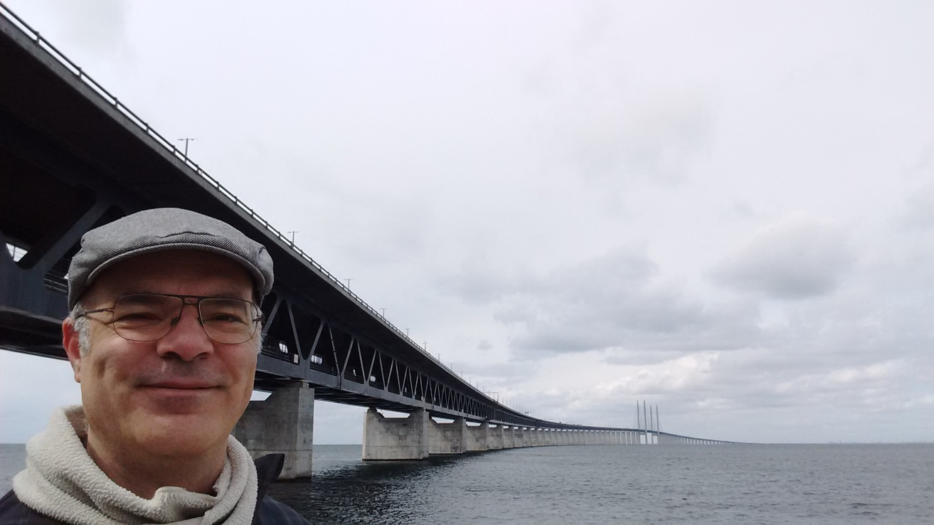 | Ali Gharavi (b.1967) is an Iranian-Swedish information technology strategy consultant, writer and playwright who has a Masters degree in Electrical Engineering. After spending some years working in the corporate sector, from 2001-10 Gharavi was head of Information Technology at the Center for Victims of Torture (CVT) based in Minneapolis, USA, an organisation providing direct support to survivors of torture and carrying out international advocacy to end torture and inhumane treatment. At CVT, Ali was responsible for Information Technology strategy and also contributed to CVT's "New Tactics for Human Rights" project. From 2010-14, Gharavi directed the "Privacy and Expression" programme at the Tactical Technology Collective, seeking to increase public awareness on issues related to privacy and security online, and to facilitate human rights defenders' access to tools and resources for digital strategy and security. For the last three years, as an independent consultant, Gharavi has collaborated with a wide range of respected human rights and development organizations (including Hivos and Front Line Defenders) on strategies for sustaining and securing human rights and development work. Gharavi has facilitated collaboration between experts in psychosocial care, protection, and digital strategy in order to provide better support to human rights defenders. He has also played a key role in pushing for better ethical and pedagogical standards in teaching and coaching NGOs on their use of information technology. Writing under the pen name of Ali Ravi, he has contributed to a number of materials for human rights defenders on these topics.  QUOTE  “We firmly believe in the principle of non-violence and working only with organisations that work with the lawful framework of these countries.”  (8 July 2017, Vatan Police Security Headquarters, Istanbul)
Peter Steudtner | 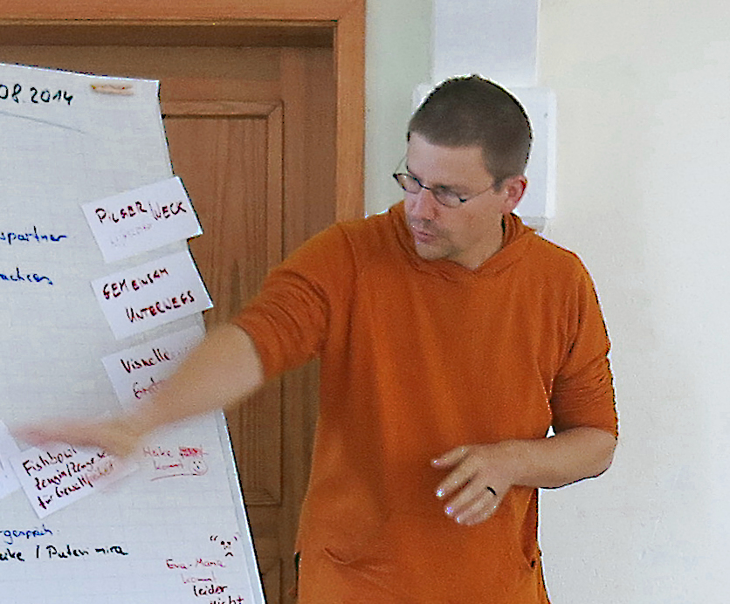 | Peter Steudtner (b. 1971) is a German trainer, coach, photographer and documentary film maker, who studied political science in Berlin. Steudtner has lived in Mozambique, first working on the psychosocial reintegration of child soldiers in local communities, and later working for several years as the Mozambique desk officer for the Development-Policy focused INKOTA Network in Berlin, before becoming an independent trainer, photographer and documentary film maker. As a trainer on non-violence, his expertise focuses on the “do-no-harm” approach, anti-discrimination work and the processing of trauma and stress in conflicts. Steudtner works in Germany as a trainer for the Center for Training and Networking on Non-violent Action 'Kurve Wustrow' in Wendland; Bread for the World Development Service and the Union for Nonviolence (Gewaltfreie Handeln e.V). Since 2011 he has led international trainings on non-violence at Kurve Wustrow, along with trainers from South Africa and Nepal. In these trainings, human rights defenders broaden their capabilities in techniques for non-violent work in the promotion of human rights; distinct approaches including health and well-being, conflict analysis, and self-reflection in conflict transformation play a role in this approach. Since 2014 Steudtner has broadened his approach to include strategic understanding of digital technology in the context of human rights work. Together with Ali Gharavi, Craig Higson-Smith and Daniel Ó Cluanaigh, he co-authored a handbook on 'holistic security', a work which explicitly explores the connection between physical, psychosocial and digital aspects of security in the context of human rights work. Since 2015 he has been a consultant with HIVOS, an international development organization, to provide support in the field of information security to human rights organizations in countries including Angola, Kenya and Mozambique. In cooperation with a local group, he has developed a number of documentary films regarding land grabbing, agricultural development and environmental and human rights-related conflicts in Mozambique.  QUOTE  “Supporting human rights defenders and their organisations are not a crime but a right.”  (8 July 2017, Vatan Police Security Headquarters, Istanbul)

