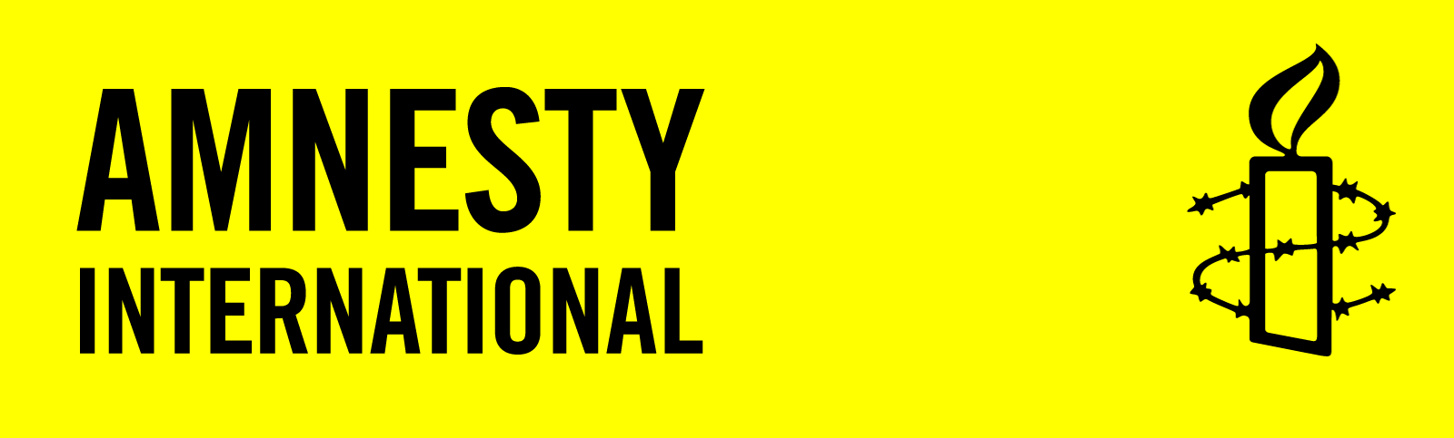
Dear Prime Minister Trudeau:
Some 6 million people have been forcibly displaced during decades of armed conflict in Colombia. At least 8 million hectares of land have been abandoned or misappropriated as a result. The impact has been particularly acute for Indigenous, Afro-descendant and peasant farmer communities whose identities and livelihoods are intimately linked with the land on which they live and work. Those seeking to return to their lands, or to defend them from the imposition of resource extraction, continue to be threatened, attacked and forcibly displaced.
Canada’s free trade agreement with Colombia creates responsibilities. We call on you to:
- Press for effective protection of the rights and safety of individuals and entire communities seeking to regain or protect their lands.
- Ensure Canadian-based companies do not operate on land illegally appropriated through human rights abuses or on land belonging to, occupied or claimed by Indigenous or Afro-descendant communities without the free, prior and informed consent of those communities.

If you include your email and phone numbers, Amnesty International will contact you about our human rights work. Your email and phone numbers will not be sent to the Myanmar government.

CANADA: Uphold Land Rights in COLOMBIA
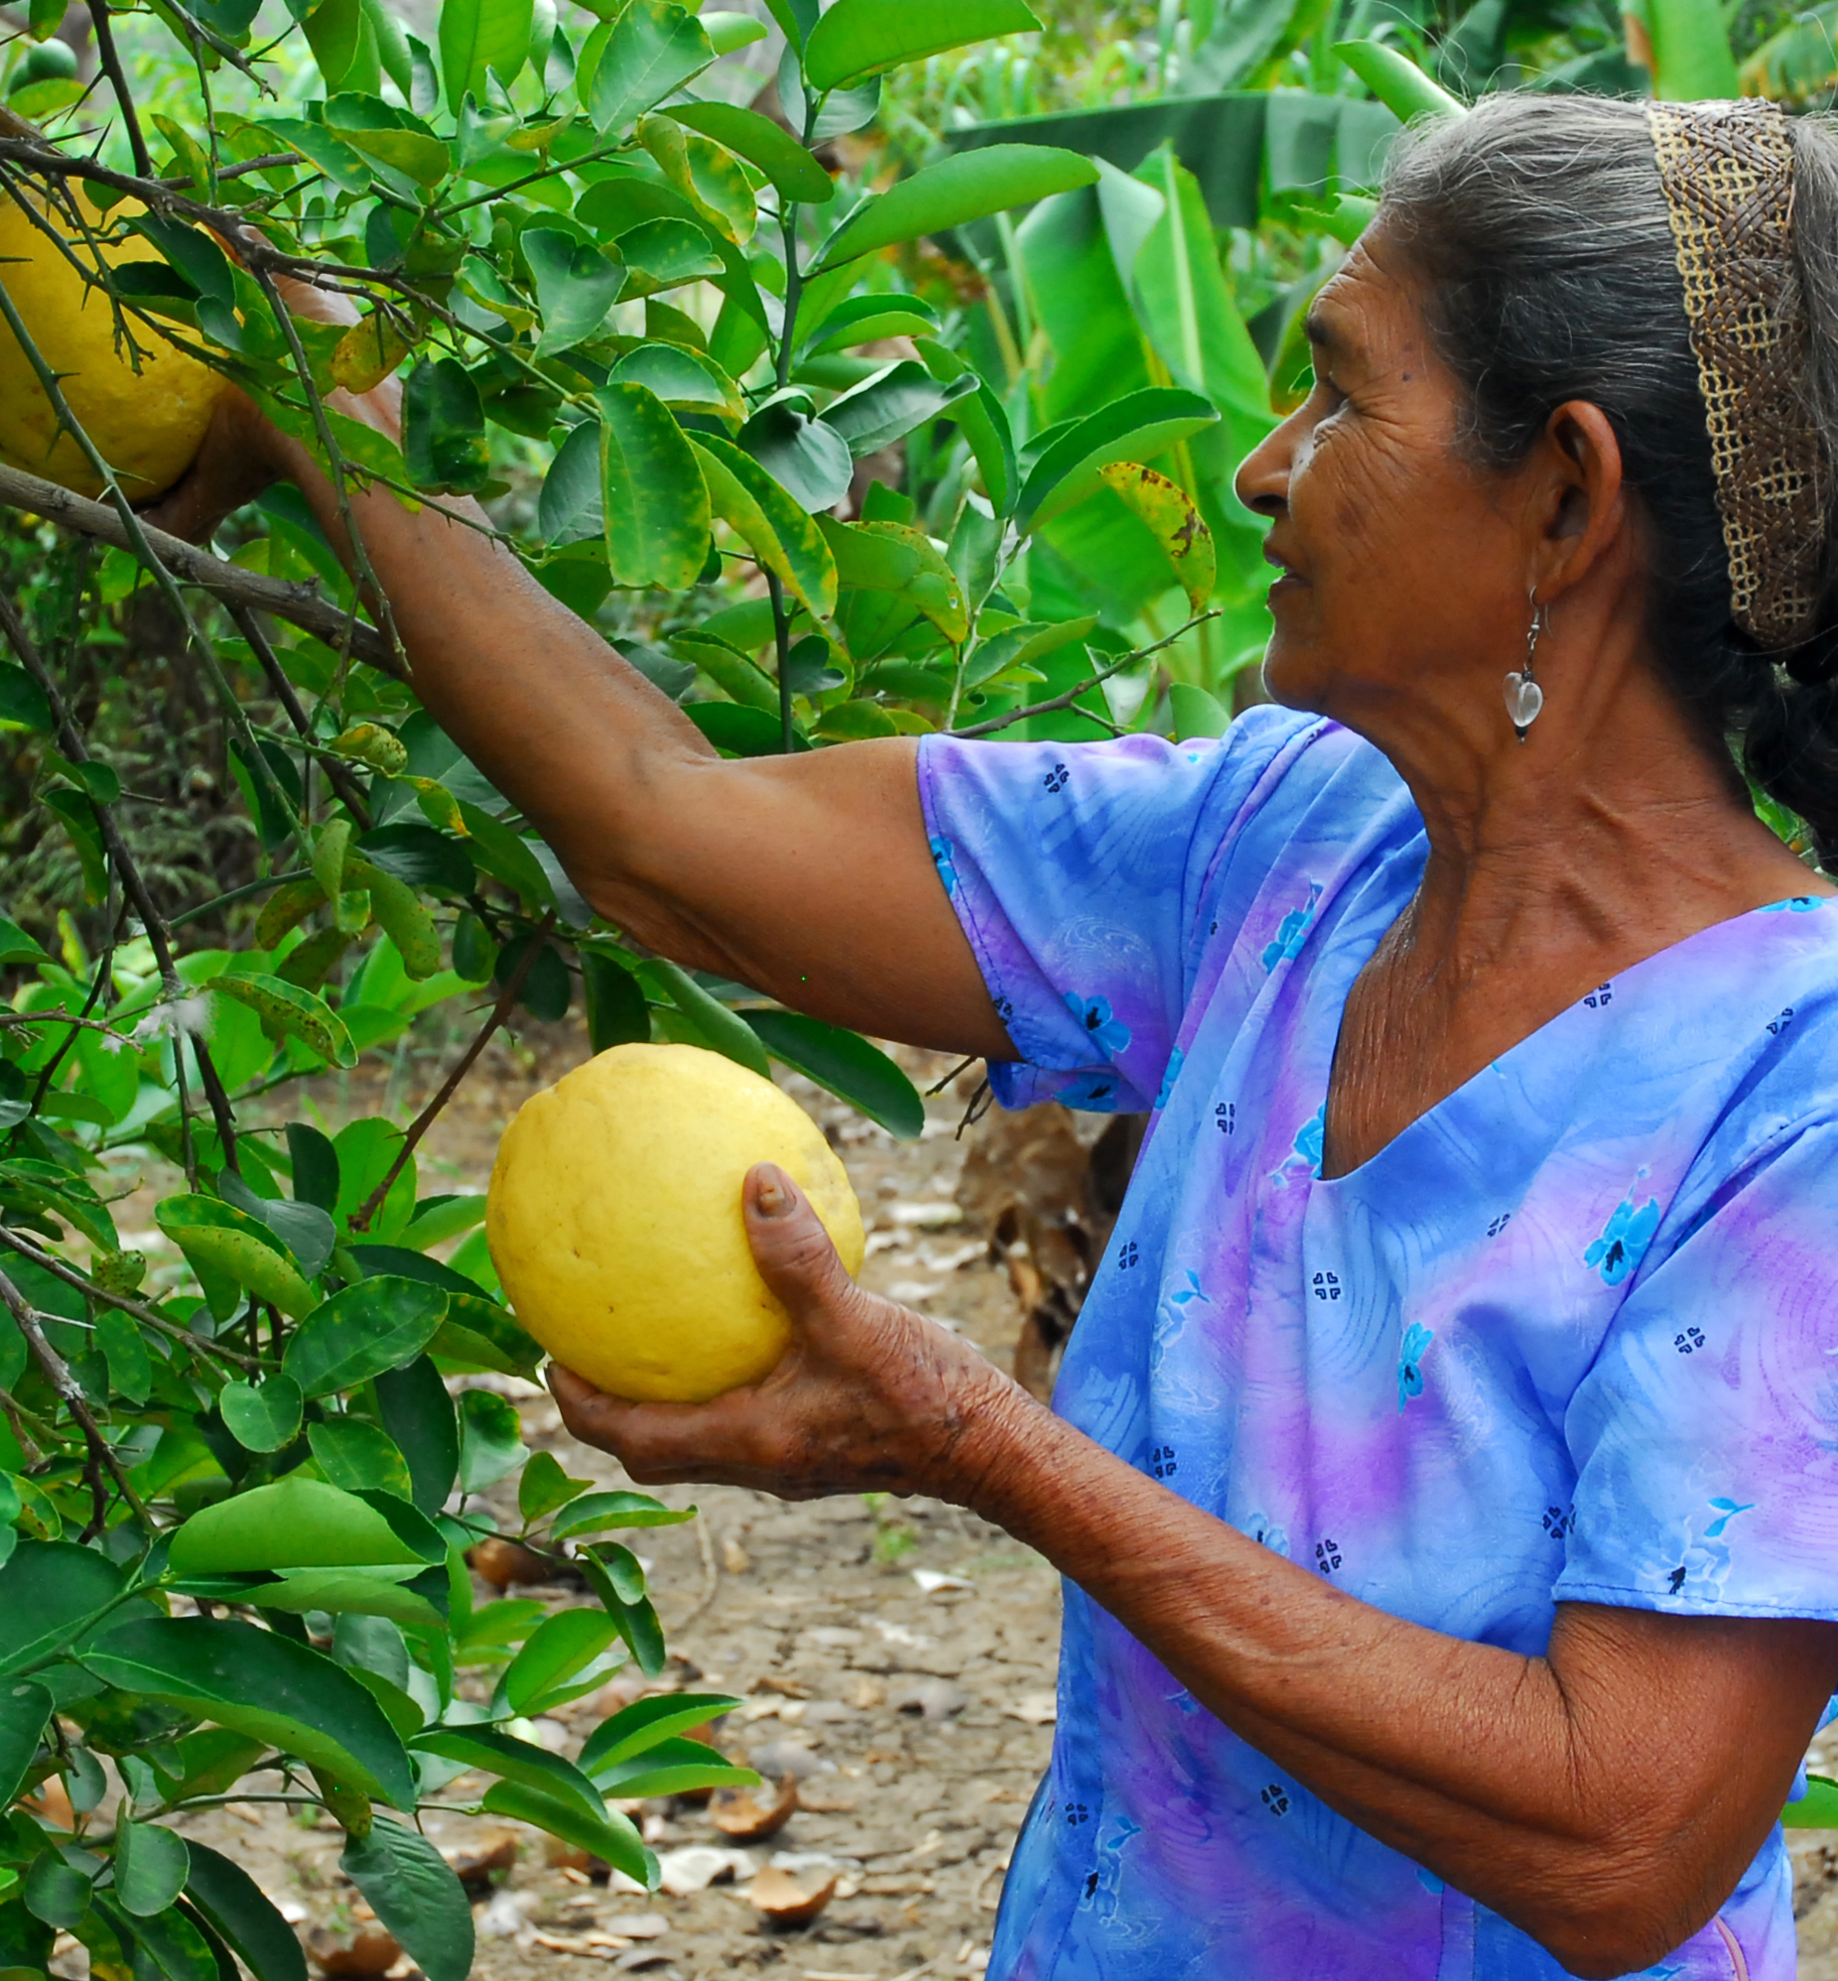
 |  |  | I wish to receive email alerts and updates about Amnesty’s human rights work (1-2 times per month)
Name (please print) | Address (include postal code) | Signature | Phone and Email

Petition created: November 2015
Please submit petition by June 2016 to:
Amnesty International Canada
1992 Yonge Street
Toronto, ON M4Y 1K2
Attention: Kathy Price
Contact: kprice@amnesty.ca.

BACKGROUND

Decades of armed conflict in Colombia have been fueled by ruthless efforts to steal or take control of land and resources. More than 260,000 peoples have been killed, most of them civilians, and tens of thousands abducted or forcibly disappeared. As many as 6 million people have been forced to flee for their lives. At least 8 million hectares of land, some 14% of Colombian territory, have been abandoned or forcibly appropriated as a result.

Many of the displaced have been targeted as part of a deliberate policy to remove people from areas rich in natural resources. For those willing to commit human rights abuses, forcibly removing the inhabitants and snatching their land open up the possibility of large profits. The temptation is all the greater given that very few of those suspected of responsibility for these crimes have been brought to justice.

Canadian resource and mining companies have secured government permits to operate in Colombia, amidst complaints by Indigenous peoples and Afro-descendant communities that their right to decision-making about projects that will impact their land is routinely denied. Indeed expressing opposition to projects brings threats and attacks. Through the Canada-Colombia Free Trade Agreement, the Canadian government is promoting further expansion of resource extraction projects without human rights guarantees.

- Sending in petitions: Once this petition is completed, please submit it within a week to Amnesty International in Toronto, ON at the address listed on the petition.

- Take the next step:
  - To learn more about this issue visit http://www.amnesty.ca/sites/amnesty/files/Colombia%20Land%20-%20Briefing%20ENG.pdf
  - Follow us on Facebook at https://www.facebook.com/AmnestyCanadaColombia/
  - Follow us on Twitter @AmnestyNow

- Questions: If you have any questions about this petition or other actions you can take on this issue, please contact Colombia Campaigner Kathy Price at kprice@amnesty.ca or (416) 363-9933 ext. 322.
CANADA: UPHOLD LAND RIGHTS IN
COLOMBIA


