TIMELINE - DRAFT
[Timeline – in 2 decks / split screen images –16 entries]
Esther’s life with Shell
1958
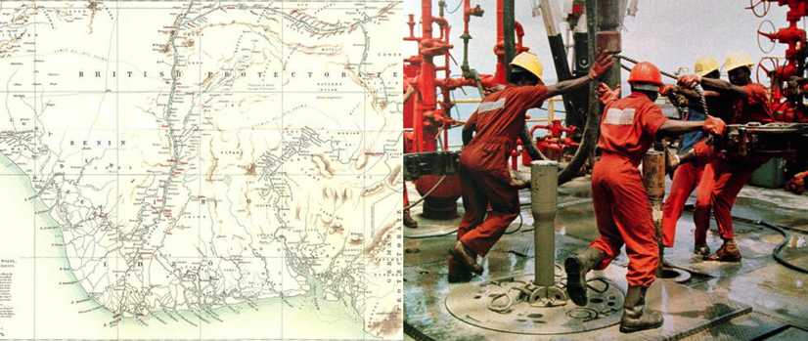
Shell discovers oil in Nigeria’s Ogoniland. Esther Ita is born in nearby Port Harcourt six years later.
1990
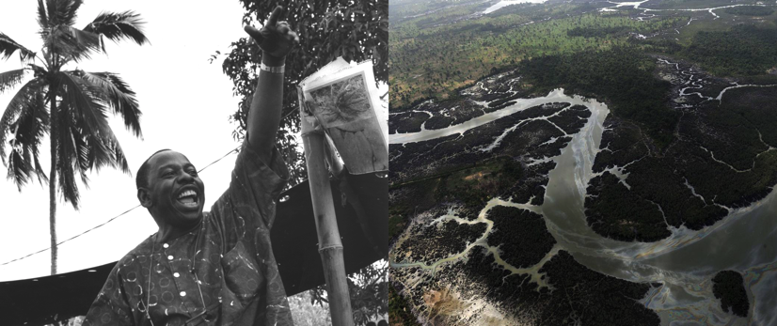

Writer Ken Saro-Wiwa, and other prominent Ogonis, launch the Movement for the Survival of the Ogoni People (MOSOP) in protest against oil pollution. Armed police kill dozens of people protesting against Shell at Umuechem village.
1991
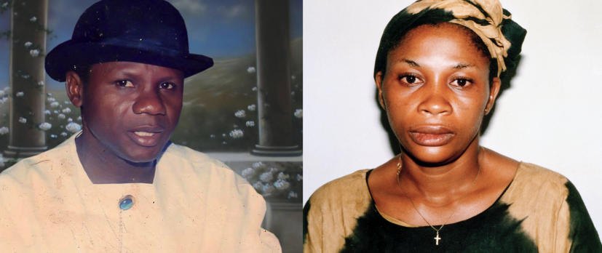

Esther, now a professional caterer, marries Barinem Kiobel, who is studying for a Phd at Strathclyde Business School in the UK.
January 1993
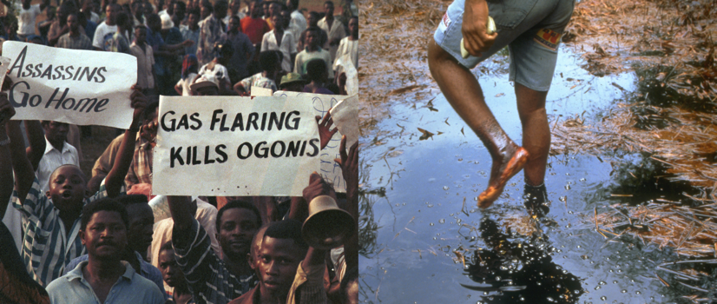

300,000 Ogonis take part in an anti-Shell protest. Soon afterwards, Shell says it is pulling out of Ogoniland for security reasons.
April 1993
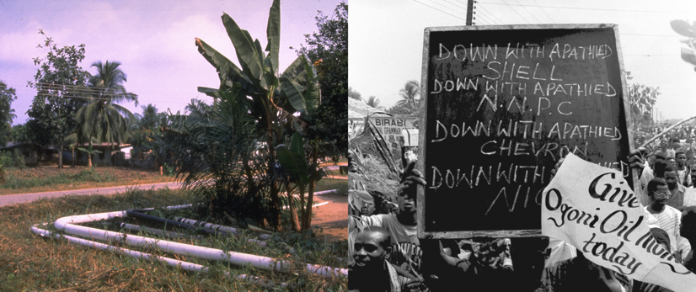

Protests take place against a US firm laying a Shell oil pipeline through Ogoniland.
June 1993
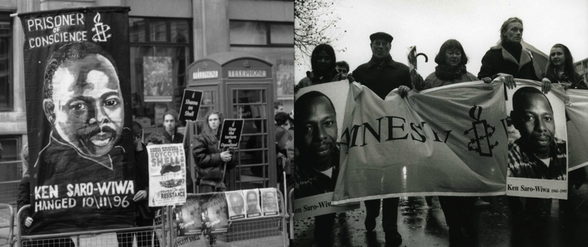

Ken Saro-Wiwa is arrested and charged in connection with the MOSOP campaign. Amnesty International declares him a Prisoner of Conscience. Suffering from health problems, he is freed a month later on bail.
July 1993
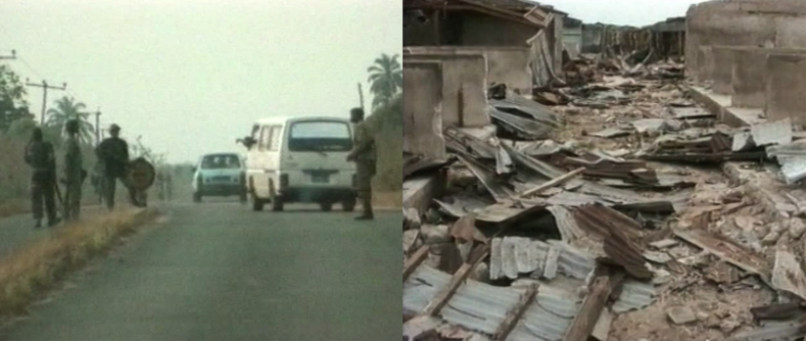
A series of armed attacks on Ogoni villages starts. The government blames neighbouring communities, but an independent investigation later confirms the military was involved.
January 1994

The government sets up a special military unit under Major Paul Okuntimo, to crush MOSOP. Esther’s husband Dr Barinem Kiobel takes up a senior government job.
May 1994

Four Ogoni chiefs are murdered. The government blames MOSOP, arresting 15 people, including Ken Saro-Wiwa and Barinem Kiobel. Amnesty launches urgent appeals for their freedom, ultimately declaring them prisoners of conscience.
February 1995
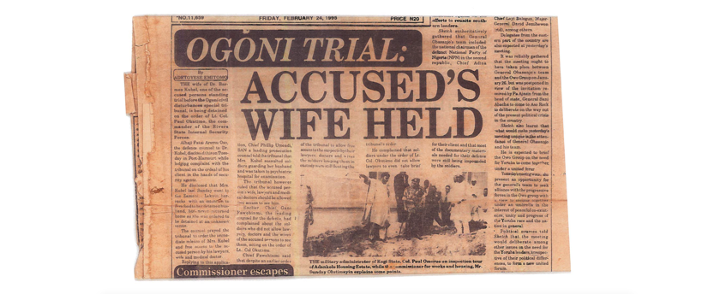

When visiting her husband in prison, Esther is assaulted by (now) Lt. Colonel Paul Okuntimo, the military commander guarding him. She is detained for two weeks. Two prosecution witnesses say the government offered bribes, including jobs with Shell, if they incriminated the accused. Shell denies any involvement.
October 1995
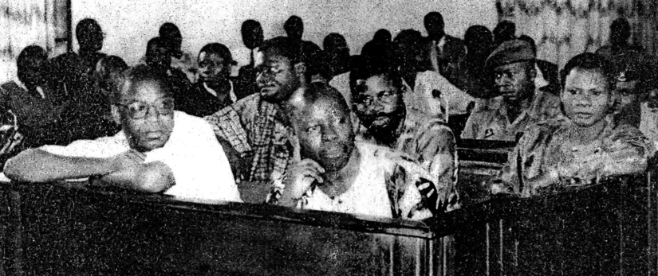
Following a blatantly unfair trial, Ken Saro-Wiwa, Dr Barinem Kiobel and seven others are convicted and sentenced to death on 30-31 October, prompting global protests.
November 1995
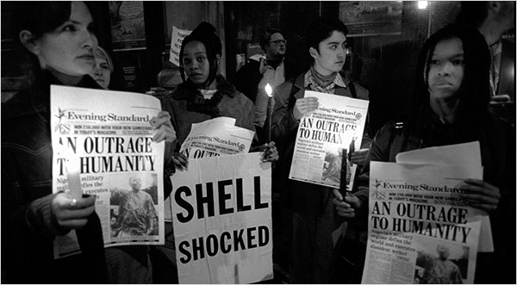

The nine convicted men are hanged in Port Harcourt on 10 November. Their bodies are dumped in an unmarked grave. Amnesty condemns the hangings. Esther’s battle for justice begins.
1996
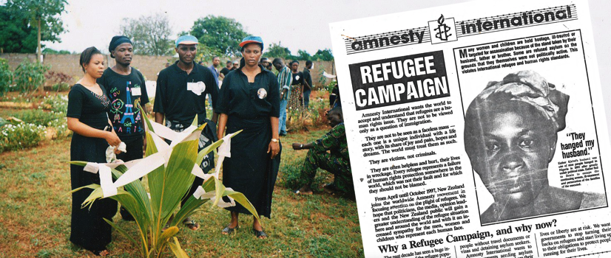
Fearing for her life, Esther flees Nigeria and lives as a refugee in Benin. Amnesty helps her gain asylum in the USA in 1998.
2002
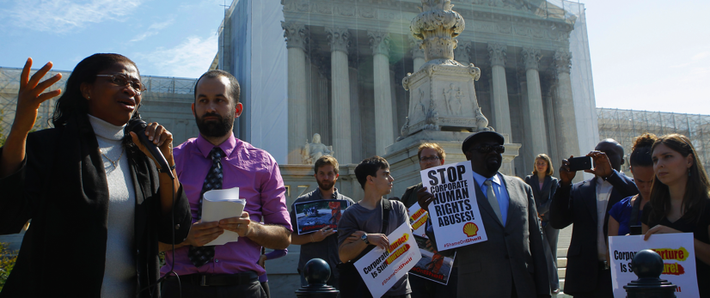
Determined that Shell accounts for its role in her husband’s death, Esther takes them to court in the USA.
2013
[need pic]
The Supreme Court rules that the USA is not the correct jurisdiction for the case to be heard. Esther’s hopes of finally airing the evidence against Shell in court are dashed.
2017
Esther takes Shell to court in the Netherlands – possibly her last chance at justice after 22 years fighting.

