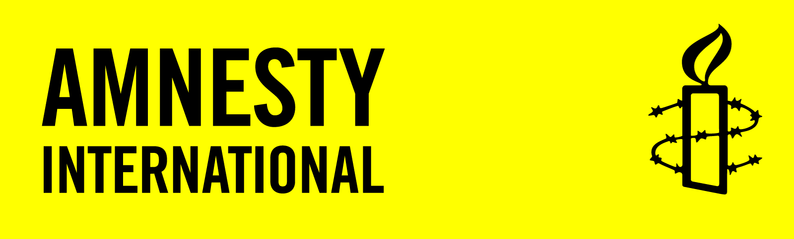
Jennifer Ritchey
Acting Field Officer for the Philadelphia Field Office
Immigrations and Customs Enforcement

Dear Ms. Ritchey

Four young children and their mothers are seeking asylum in the US after escaping horrific violence in their home countries. They have been held at a US Immigration and Customs Enforcement centre in Pennsylvania for over 500 days despite having pending applications for legal permanent residency.

I call on you to:
- immediately release on parole those granted SIJ status and their mothers who are detained at Berks County Residential Center.
- ensure that they are provided necessary medical attention, in accordance with their wishes.
- ensure that while in detention, they will be provided regular contact with family members and lawyers of their choosing.

I urge you to:

If you include your email and phone numbers, Amnesty International will contact you about our human rights work. Your email and phone numbers will not be sent to the Myanmar government.

United States: Free #theBerksKids
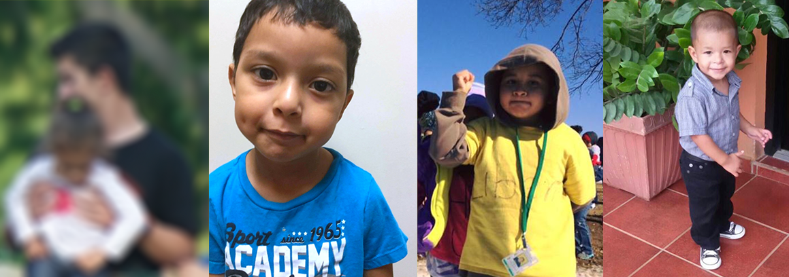
 |  |  | I wish to receive email alerts and updates about Amnesty’s human rights work (1-2 times per month)
Name (please print) | Address (include postal code) | Signature | Phone and Email

Petition created: April 4 2017
Please submit petition by 30 June 2017 to:
Amnesty International Canada
1992 Yonge St. 3rd Fl.
Toronto ON M4S 1Z7
Contact: gnafziger@amnesty.ca

